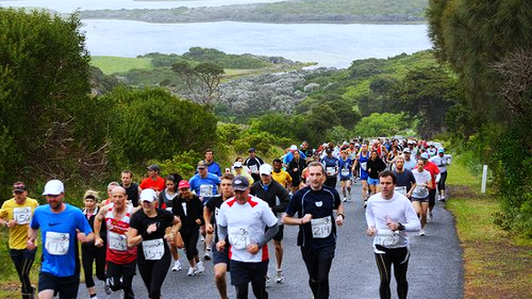

34th 3 Bays Marathon Entrant Handbook

November 5th 2017

Table of Contents
Registrations / Withdrawals 3
Entry packs 3
Directions 3
Start times 3
Start Procedure 4
Event Information 4
Course Map / Markings 6
Event Rules / Course Etiquette 6
Baggage Drop 6
Car Parking 7
Aid Stations 7
Special Drinks / Nutrition 7
Toilets 7
Personal Music Devices 7
Relay Vehicle Information 8
Presentations 8
Prizes 8
Photos 9
Results 9
Accommodation 9
Weather 10
Sponsors 11
11
Volunteers 11

Registrations / Withdrawals

Registrations will be accepted online up until 5.00pm Friday 3rd November. Late registrations will be accepted at the Upwelling Festival at the Portland Foreshore on November 4th between 10am and 4pm. No registrations will be accepted after 4pm November 4th. Any late registrations will incur a $20 late registration fee for all events. Registrations will NOT be accepted on the day.

Entry packs

Entry packs can be collected from the Portland Runners Club stall at the Portland Upwelling Festival from 10.00am to 4.00pm on Saturday 4th November. Entry packs / race bibs can be collected from the Marathon start line from 5.30am on Sunday 5th November and must be collected prior to the race briefing for each event. There will be a caravan at the corner of Blair and Otway Streets.

Directions

From Melbourne: Take the Portland exit from the Princes Highway and follow the Henty Highway / Percy Street. Turn right at the second roundabout – Otway Street. The Startline is opposite the Big O Milkbar, 45 Otway Street, Portland.

From South Australia: Follow the Henty Highway / Percy Street and turn right at the first round about – Otway Street.

Start times

Marathon Walk 6:00am
4 person Relay Walk 6.30am
Marathon Run 8.00am
4 & 8 person Relay Run 8.15am
½ Marathon Walk 9:45am
½ Marathon Run 9.45am
¼ Marathon Run/Walk 9:45am

Race briefing will occur 10 minutes prior to the commencement of each event. All briefings will occur on the course at the event start lines.

Start Procedure

A race briefing will occur 10 minutes prior to the commencement of all events. Please ensure you are at the start line for this briefing. A siren will signal the start of all events, please adhere to all race rules from this point.

Event Information

Marathon Run
Start Time | 8:00am
Start Location | 45 Otway Street
Race brief | 7:50am
Presentations | 1:00pm
Cut Offs | Course will be reopened to traffic at 2:00pm
Aid Stations | 5km, 10km, 15km, 20km, 25km, 30km, 35km, 40km

Marathon Walk
Start Time | 6:00am
Start Location | 45 Otway Street
Race brief | 5:50am
Presentations | 1:00pm
Cut Offs | Course will be reopened to traffic at 2:00pm
Aid Stations | 5km, 10km, 15km, 20km, 25km, 30km, 35km, 40km

½ Marathon Run
Start Time | 9:45am
Start Location | Bridgewater Lakes – 21.1km mark
Bus to Start Line | Buses leave Otway Street Start Line at 8:45am
Race brief | 9:35am
Presentations | 1:00pm
Cut Offs | Course will be reopened to traffic at 2:00pm
Aid Stations | 4km, 9km, 14km, 19km

½ Marathon Walk
Start Time | 9:45am
Start Location | Bridgewater Lakes – 21.1km mark
Bus to Start Line | Buses leave Otway Street Start line 8:45am
Race brief | 9:35am
Presentations | 1:00pm
Cut Offs | Course will be reopened to traffic at 2:00pm
Aid Stations | 4km, 9km, 14km, 19km

4 Person Relay Walk
Start Time | 6:30am
Start Location | 45 Otway Street
Race brief | 6:20am
Presentations | 1:00pm
Cut Offs | Course will be reopened to traffic at 2:00pm
Aid Stations | 5km, 10km, 15km, 20km, 25km, 30km, 35km, 40km

Marathon Relay Runs (4 and 8 Person & School Relays)
Start Time | 8:15am
Start Location | 45 Otway Street
Race brief | 8:05am
Presentations | 1:00pm
Cut Offs | Course will be reopened to traffic at 2:00pm
Aid Stations | 5km, 10km, 15km, 20km, 25km, 30km, 35km, 40km

Quarter Marathon Run
Start Time | 9:45am
Start Location | Oakleys Rd
Bus to Start Line | Buses leave Otway Street Start line at 9:00am
Race brief | 9:35am
Presentations | 1:00pm
Cut Offs | Course will be reopened to traffic at 2:00pm
Aid Stations | 3km, 8km

Course Map / Markings

All participants in the individual and team events will use the same course. Please remember to be courteous to all participants and adhere to the course rules.
Full marathon events, including relays will start from outside the Big O milk bar on Otway Street Portland.

The half marathon events will commence from the 21.1 km mark which is located just past the entrance to the Bridgewater Lakes.

The quarter marathon events will commence just back along Oakleys Rd which is at the 31.5km mark
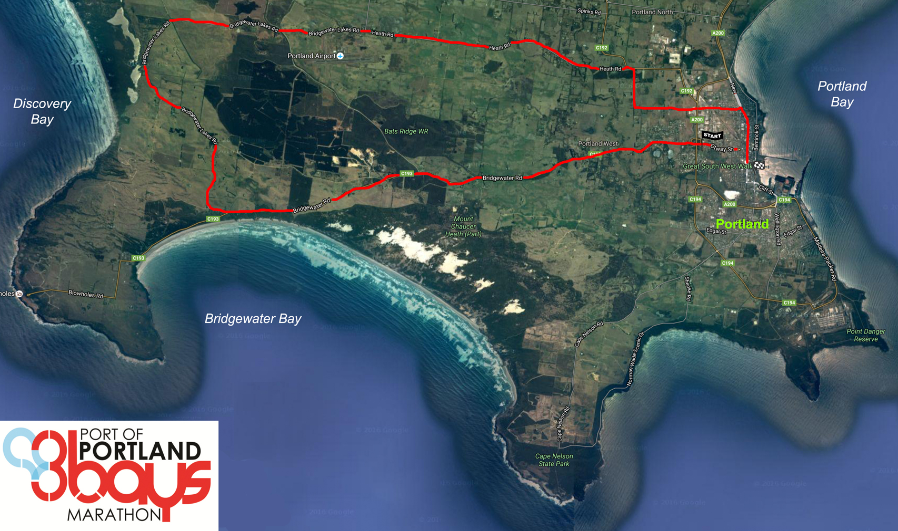

The finish line for all competitors is on Bentick Street outside of the Thistle Bar and Bistro.
The course will be marked at 1km intervals and the drink stations are located at 5km intervals approximately.

Event Rules / Course Etiquette

- Runners and walkers are to stay on the right side of the road, with the exception of the Bentinck Street section where you are to stay on the left. Marshals will inform you of this at the appropriate stage.
- Number bib with embedded timing chip must be worn by the competitor at all times. If not, your time can not be recorded. For relay teams, the final runner/walker must be wearing the bib fitted with a timing chip.
- Please follow the instructions of course marshals at all times
- Course marshals have the authority to disqualify or remove entrants from the course if it is deemed that they have disobeyed course rules or their safety is at risk.

Baggage Drop

Clothing and other personal belonging can be left at the caravan at the Otway Street start line, or left at the start line for competitors in the half and quarter marathon events. A bag will be provided in your race packs and will be identified by your race number. Baggage can be collected from the baggage tent at the finish line. Please have your race number ready for the volunteers at the baggage tent.

Car Parking

Car parking is available around the start line. Please be aware that there may be a large amount of cars in the area at the commencement of events. Please also be respectful of private driveways and local traffic.

Aid Stations

Aid stations are located every 5km and water will be available at all stations. Bananas and sports drinks will be available at the 20km, 30km aid stations.

Special Drinks / Nutrition

Special drinks and nutrition can be left at the caravan at the Otway Street Start line. This needs to be completed by 7.30am AT THE LATEST. Please include a note with instructions regarding the aid stations that you would like your items to be available.

Toilets

Portable toilets will be located on Blair Street (next to the Caravan at the start line). There are toilets located at Bridgewater lakes where participants completing the half marathon will be dropped off prior to their event. A portable toilet will be located at the start of the quarter marathon. Facilities are also available for participants to use at the Thistle Bar and Bistro at the finish line. There are also public toilets located approximately 100m from the finish line

Personal Music Devices

The use of personal music devices in not recommended to ensure your own safety and the safety of the others on the course. If you must use a personal music device, please ensure that the volume is low enough so that you can still hear traffic and other competitors around you.

Relay Vehicle Information

SAFETY IS OUR MAJOR CONCERN – PLEASE THINK OF ALL OTHER ROAD USERS AND BEHAVE RESPONSIBLY
Note that a 40kph speed limit will be enforced right around the course.
1. Police will be present and will fine drivers who behave irresponsibly.
2. Vehicles transporting relay runners/walkers to display sign (supplied with Team No's) on left hand side of windscreen. Limit of two (2) vehicles per team.
3. NO team vehicle (CAR, VAN or BIKE) is to follow OR DRIVE BESIDE team runners/walkers or disrupt other runners/walkers. The road is narrow and will be very busy. Please obey this instruction.
Course marshals will report any vehicle breaking rules and teams/individuals may be disqualified.
4. ALL vehicles to leave the START area after the relay team briefing is completed and before the relay race starts.
5. Please assist at change over points by parking well clear of area and keeping roadway clear for the runners & walkers.
6. Please drive carefully and watch out for tired runners/walkers as they might veer across roadway in front of vehicle.
7. Bentinck St, where the Finish line is, will be blocked off to vehicles until 2pm.
8. Thank you for helping to keep this event safe, ensuring that it will continue to be the great success it has been in the past.

Presentations

Presentations will commence at midday for participants in the primary and secondary school relays. Presentations will be held in the Blue Room of the Thistle Bar and Bistro.

Presentations for all other events will commence at 1:00pm in the Blue Room. Participants in all individual events will receive their participation medals at the finish line.

Prizes

Prizes will be awarded to the first 3 place getters in all individual events. These can be collected from the finish line. Prizes have been donated and sourced from local businesses, please support these businesses where possible.

Photos

Photographers will be located strategically around the course. There will also be a photographer stationed at the finish line. These photos may be used for promotional purposes and may feature in Runners World magazine, online at the Portland Runners Club Website, in local media sources, on social media and on future promotional material.
Should you not wish to have your photograph published, please contact the Portland Runners Club at portlandrunnersclub@hotmail.com

Results

Results will be published online following the conclusion of the event. An email will be sent to participants informing them of the availability of results. Results will also be posted on the Portland Runners Club website – www.portlandrunnersclub.com.au and on Facebook.

Accommodation

Portland is located in the picturesque South West of Victoria, approximately 4.5 hours south west of Melbourne. Whilst in town for the marathon events, why not take to opportunity to take in the beautiful beaches, nature walks and historical sights that the South West has to offer. There are a number of accommodation options in the area to accommodate all of your needs.

http://www.portlandaccom.com.au
http://www.visitportland.com.au

Weather

As Portland is a coastal area, the weather can be unfavourable at times!!! Whilst every effort to ensure that the event goes ahead will be made, the safety of participants is the primary concern. Please note that the event will only be cancelled in the event of extreme weather – winds 100km+, extreme heat (very unlikely!!). In the event of cancellation due to weather, participants will be informed as soon as possible.

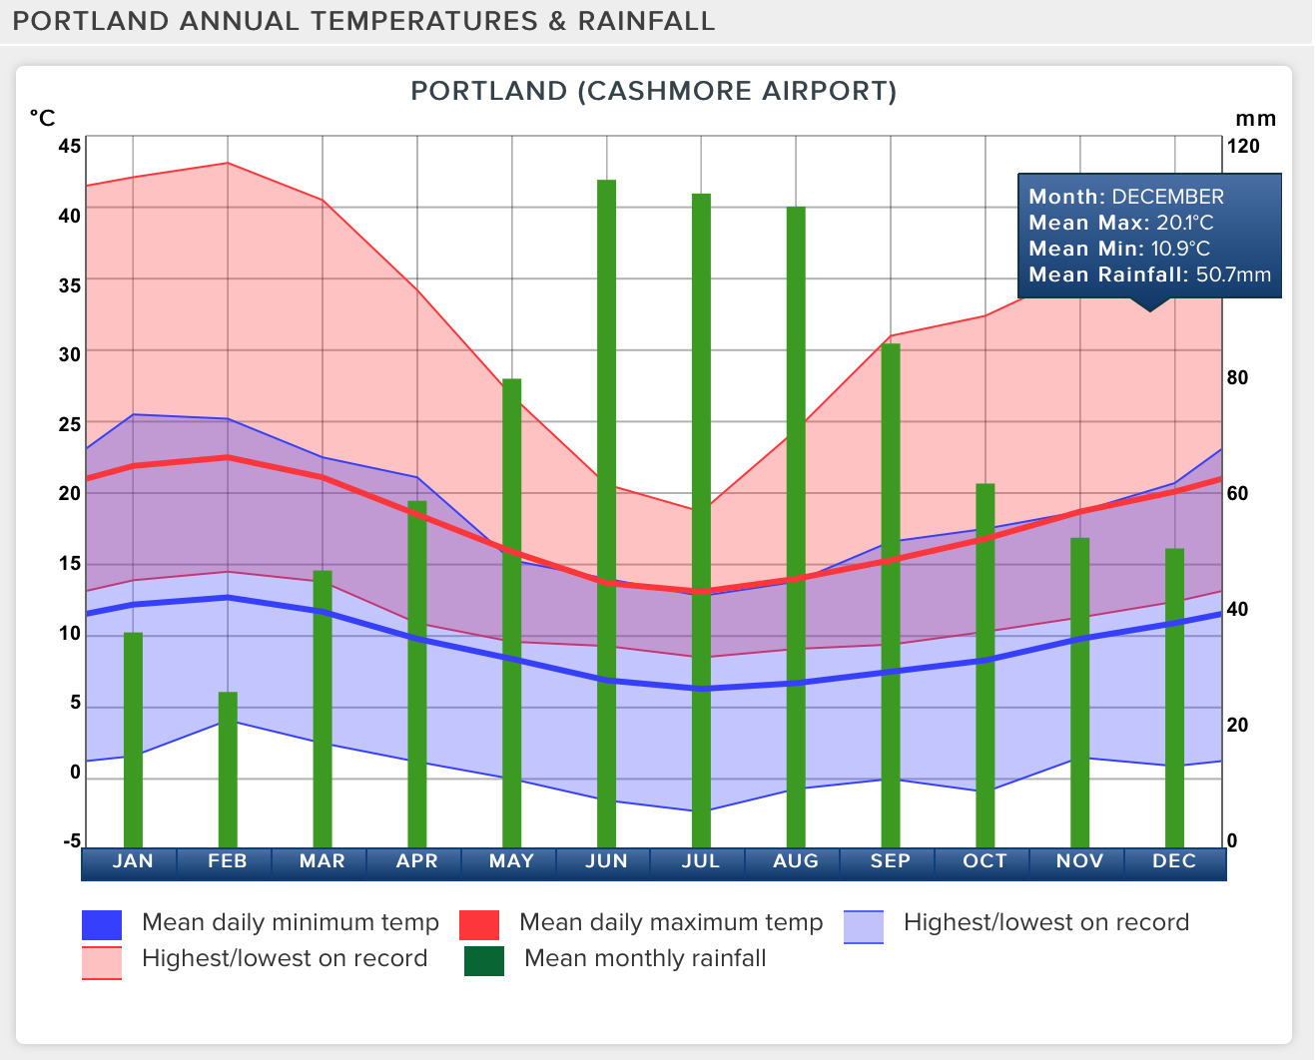

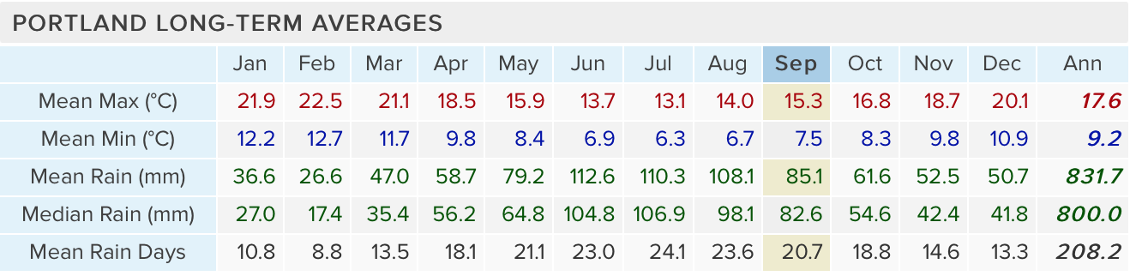

Sponsors

Portland Runners Club would like to thank the following sponsors for their support of the 2017 3Bays Marathon event. We are grateful for their support of this local event. Please remember to support the local businesses whenever possible.

Volunteers

Without the tireless work of our volunteers, this event would not be the success that it is. They are out on the course hours before you and they are cleaning it up after you have left. Please make sure that you show them some support!

Also a big thanks to the aid station volunteers:

- Portland District Health
- Portland Surf Lifesaving Club
- Portland Young Professionals Network
- Portland Primary School
- Portland Masonic Project
- Westpac Bank
- Cashmore Fire Brigade
- Portland Mens Shed

For more information contact the Race Director, Dion Gallagher on 0404 800 073.

On behalf of the Portland Runners Club, we wish you all the best on completing the 34th Port of Portland 3Bays Marathon. Thank-you for your support of our event!

